Unit 1 Test Review
This review goes over Introduction to Limits, Infinite Limits and Limits at Infinity, the Derivative, and Basic Differentiation Properties
Limits from Graph
- For Questions 1-12, use the graphs to evaluate the respective indicated limits and function values. If the limit does not exist, write DNE.
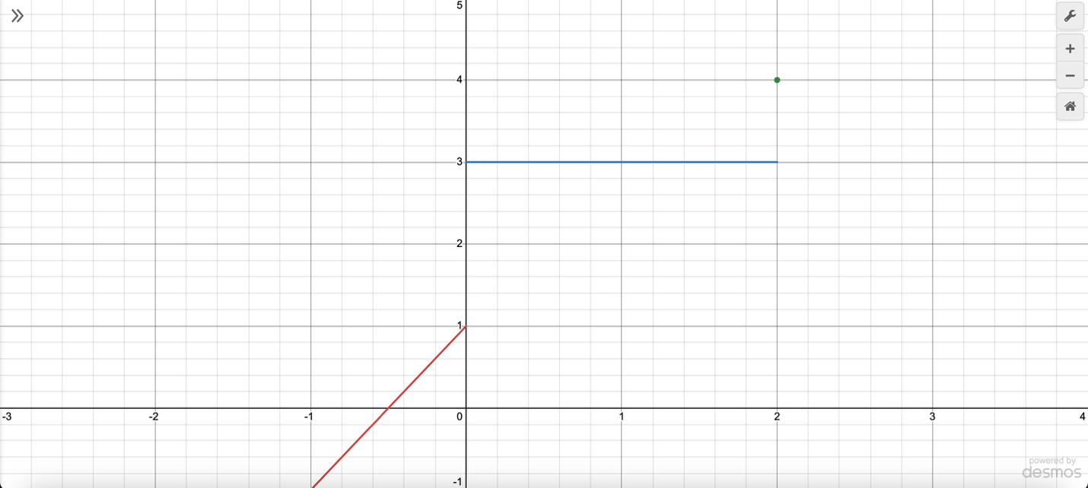
- Find $\lim_{x→-1}{f\left(x\right)}=$

- Find $\lim_{x→2}{f\left(x\right)}=$

- Find $\lim_{x→0}{f\left(x\right)}=$

- Find $f(2)=$

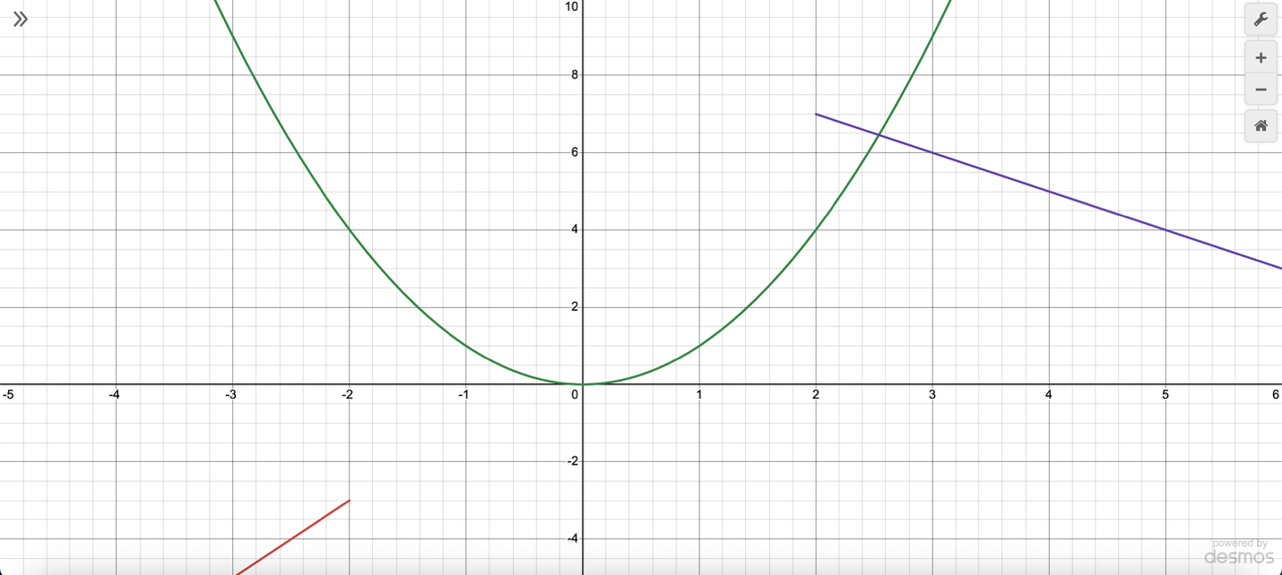
- Find $\lim_{x→3}{f\left(x\right)}=$

- Find $\lim_{x→-2}{f\left(x\right)}=$

- Find $\lim_{x→1}{f\left(x\right)}=$

- Find $f\left(-2\right)=$

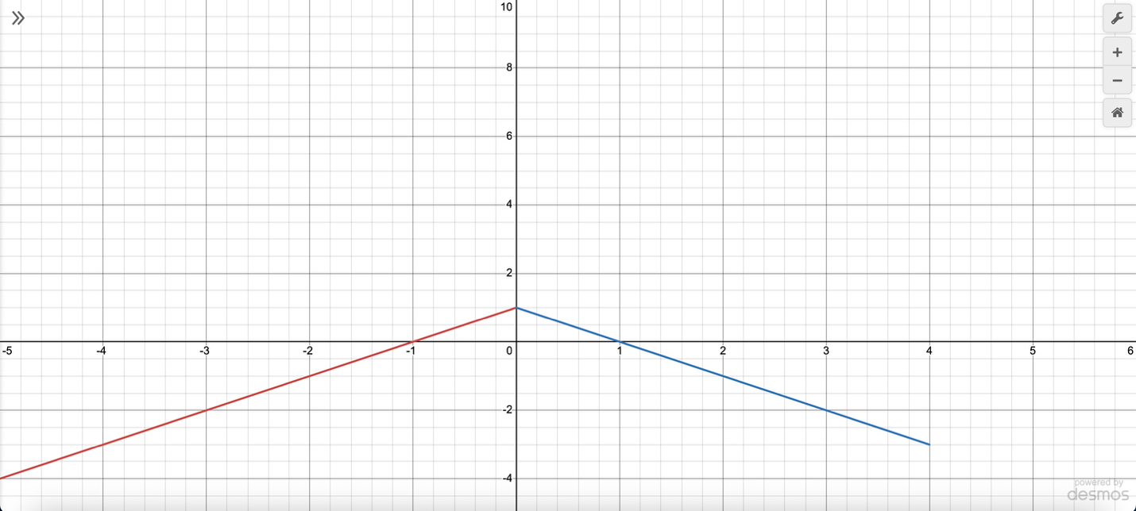
- Find $\lim_{x→0}{f\left(x\right)}=$

- Find $\lim_{x→4}{f\left(x\right)}=$

- Find $\lim_{x→-1}{f\left(x\right)}=$

- Find $f\left(4\right)=$

Piecewise Function Limits
- For Questions 13-15, find the limit if it exists, using the following piecewise functions:
- $f\left(x\right)=\left\{\begin{aligned}10-2x^{2}, for x≤2 \\ x^{2}+4, for x>2\end{aligned}\right.$
  - Find $\lim_{x→2^{-}}{f\left(x\right)=}$

  - Find $\lim_{x→2^{+}}{f\left(x\right)=}$

  - Find $\lim_{x→2}{f\left(x\right)=}$

- $f\left(x\right)=\left\{\begin{aligned}5x-7, for x≤0 \\ x^{2}+2x, for x>0\end{aligned}\right.$
  - Find $\lim_{x→0^{-}}{f\left(x\right)=}$

  - Find $\lim_{x→0^{+}}{f\left(x\right)=}$

  - Find $\lim_{x→0}{f\left(x\right)=}$

- $f\left(x\right)=\left\{\begin{aligned}-2x^{3}+1, for x≤3 \\ x+5, for x>3\end{aligned}\right.$
  - Find $\lim_{x→3^{-}}{f\left(x\right)=}$

  - Find $\lim_{x→3^{+}}{f\left(x\right)=}$

  - Find $\lim_{x→3}{f\left(x\right)=}$

Algebraic Limits
- Find $\lim_{x→2}{\frac{x^{2}-5x+6}{x-2}}$

- Find $\lim_{x→4}{\frac{x^{2}-7x+10}{x-2}}$

- Find $\lim_{x→5}{\frac{x^{2}-9x+14}{x-2}}$

Asymptotes
- For Questions 19-21, find the vertical and horizontal asymptotes of the following functions and sketch the graphs.
- $f\left(x\right)=\frac{x^{2}-4x+3}{x^{2}-9}$

- $f\left(x\right)=\frac{x^{2}-16}{x^{2}+6x+8}$

- $f\left(x\right)=\frac{x^{2}+5x+6}{x^{2}-x-6}$

Evaluate Limits
- For Questions 22-24, find the limits algebraically.
- $\lim_{x→5}{\frac{x-5}{x^{2}-6x+5}}$

- $\lim_{x→-3}{\frac{x+3}{x^{2}+5x+6}}$

- $\lim_{x→4}{\frac{x-4}{x^{2}-6x+8}}$

Limits at Infinity
- For Questions 25-28, evaluate the limit at infinity algebraically.
- $\lim_{x→ ∞}{\frac{3x^{2}-x+4}{2x^{2}+7x-9}}$

- $\lim_{x→ -∞}{\frac{6x^{2}+3x+1}{4x^{2}-5x-10}}$

- $\lim_{x→ ∞}{\frac{-2x^{2}+x-5}{-2x^{2}-x+8}}$

Infinite Limits
- Find the infinite limits of $f\left(x\right)=\frac{-{(x-2)}^{2/3}}{\left|x+3\right|}$ and sketch the graph.
  - $\lim_{x→3^{-}}{f\left(x\right)=}$

  - $\lim_{x→3^{+}}{f\left(x\right)=}$

  - $\lim_{x→3}{f\left(x\right)=}$

- Find the infinite limits of $f\left(x\right)=\frac{{(x+5)}^{2/3}}{\left|x-2\right|}$ and sketch the graph.
  - $\lim_{x→2^{-}}{f\left(x\right)=}$

  - $\lim_{x→2^{+}}{f\left(x\right)=}$

  - $\lim_{x→2}{f\left(x\right)=}$

- Find the infinite limits of $f\left(x\right)=\frac{-{(x-1)}^{2/3}}{\left|x+2\right|}$ and sketch the graph.
  - $\lim_{x→2^{-}}{f\left(x\right)=}$

  - $\lim_{x→2^{+}}{f\left(x\right)=}$

  - $\lim_{x→2}{f\left(x\right)=}$

Limit Definition of the Derivative
- For Questions 31-33, find the limit definition of the derivative, $\lim_{h→0}{\frac{f\left(x+h\right)-f(x)}{h}}$, of the following function using the four steps.
- $f\left(x\right)=2x^{2}-3x+1$
  - Find $f(x+h)$

  - Find $f\left(x+h\right)-f(x)$

  - Find $\frac{f\left(x+h\right)-f(x)}{h}$

  - Find $\lim_{h→0}{\frac{f\left(x+h\right)-f(x)}{h}}$

- $f\left(x\right)=-x^{2}+6x-4$
  - Find $f(x+h)$

  - Find $f\left(x+h\right)-f(x)$

  - Find $\frac{f\left(x+h\right)-f(x)}{h}$

  - Find $\lim_{h→0}{\frac{f\left(x+h\right)-f(x)}{h}}$

- $f\left(x\right)=5x^{2}-2x+7$
  - Find $f(x+h)$

  - Find $f\left(x+h\right)-f(x)$

  - Find $\frac{f\left(x+h\right)-f(x)}{h}$

  - Find $\lim_{h→0}{\frac{f\left(x+h\right)-f(x)}{h}}$

Derivative Rules
For Questions 34-42, find the derivatives for the functions below.
- $x^{18}+7$

- $x^{12}-3$

- $x^{9}+10$

- ${4x}^{1.5}-\frac{x^{2.3}}{3}$

- ${3x}^{2.8}-\frac{{2x}^{1.6}}{5}$

- ${6x}^{1.2}-\frac{{3x}^{2.5}}{4}$

- $x^{3/4}-5x^{2/3}+3x^{-1/2}$

- ${2x}^{5/6}+4x^{-2/3}-x^{1/3}$

- ${7x}^{-1/4}-x^{3/5}+5x^{1/2}$

Rate of Change Application and Interpretation
- A computer screen company has, on average, an employee can assemble N(t) screens per day after t days of on the job training, given by $N\left(t\right)=25+60t^{-1}$, where $t≥1.5$.
  - Find the derivative

  - Find N(5) and N’(5) and interpret the results with a short sentence.

- On average, a car manufacturing company have new employees that can assemble N(t) components per day after t days of on the job training, given by $N\left(t\right)=40-50t^{-1}$, where $t≥1.5$.
  - Find the derivative

  - Find N(5) and N’(5) and interpret the results with a short sentence.

- An employee for a satellite company can, on average, assemble N(t) components per day after t days of on the job training, given by $N\left(t\right)=35+70t^{-1}$, where $t≥1.5$.
  - Find the derivative

  - Find N(5) and N’(5) and interpret the results with a short sentence.

Tangent Line
- For Questions 46-48, use each function to:
- Find the exact point where the tangent line is passing at x = 1
- Find the slope of the graph at x = 1
- Find the equation of the tangent line at x = 1

- $f\left(x\right)=2x^{5}-4x^{2}+6$

- $f\left(x\right)=-3x^{4}+x^{3}-1$

- $f\left(x\right)=x^{3}-5x+8$

Tangent Line
- For Questions 49-51, find the following:
- Find the ordered pair
- Find the slope
- Use point-slope form to find the tangent line

- $f\left(x\right)=2x^{5}-4x^{2}+6$ at x = 2

- $f\left(x\right)=-3x^{4}+x^{3}-1$ at x = -1

- $f\left(x\right)=x^{3}-5x+8$ at x = 0

Average Rate of Change
- The function $f\left(x\right)=2x^{2}-3x$ represents an object in motion, when x is seconds and f(x) is meters. Find the average velocity from 1 to 4 seconds.

- The function $y=-x^{2}+5x$ represents an object in motion, when x is seconds and y is meters. Find the average velocity from 0 to 3 seconds.

- The function $f\left(x\right)=x^{2}-4x+6$ represents an object in motion, when x is seconds and f(x) is meters. Find the average velocity from 2 to 5 seconds.

