Unit 1 Test Review KEY
This review goes over Introduction to Limits, Infinite Limits and Limits at Infinity, the Derivative, and Basic Differentiation Properties
Limits from Graph
- For Questions 1-12, use the graphs to evaluate the respective indicated limits and function values. If the limit does not exist, write DNE.
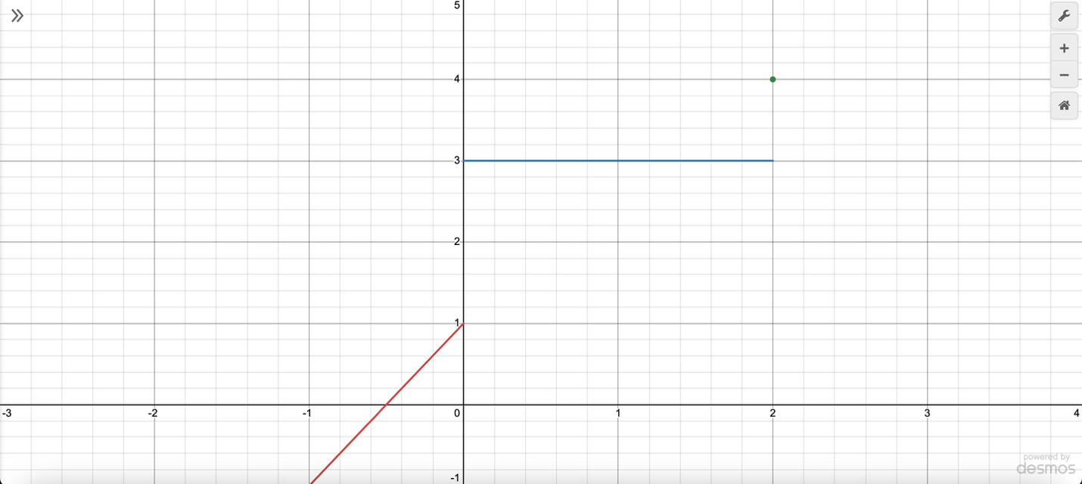
- Find $\lim_{x→-1}{f\left(x\right)}=-1$
- Find $\lim_{x→2}{f\left(x\right)}=3$
- Find $\lim_{x→0}{f\left(x\right)}=DNE$
- Find $f(2)=4$

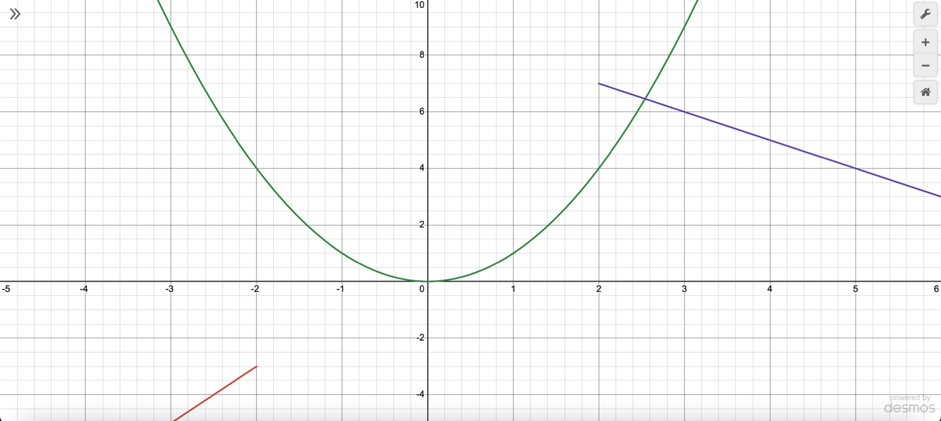
- Find $\lim_{x→3}{f\left(x\right)}=6$
- Find $\lim_{x→-2}{f\left(x\right)}=4$
- Find $\lim_{x→1}{f\left(x\right)}=1$
- Find $f\left(-2\right)=4$

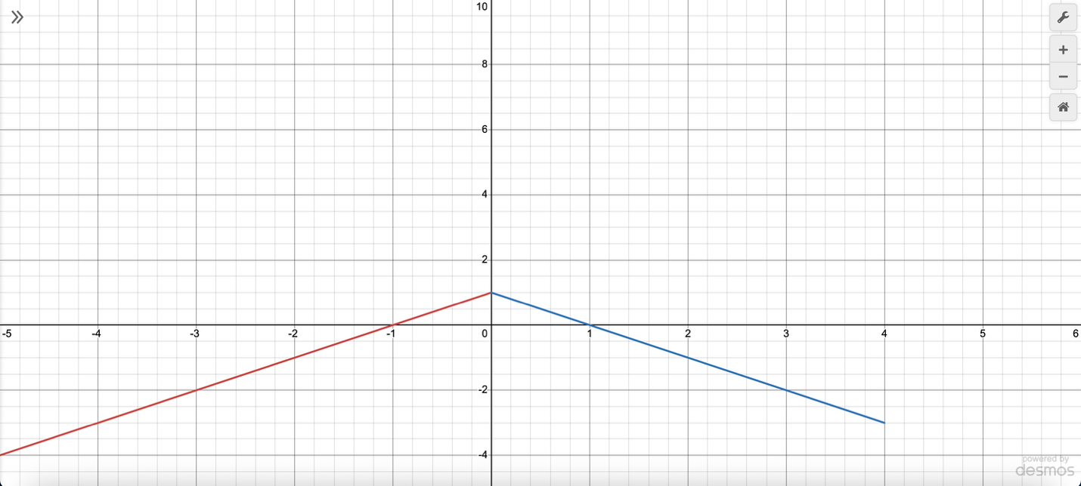
- Find $\lim_{x→0}{f\left(x\right)}=1$
- Find $\lim_{x→4}{f\left(x\right)}=-3$
- Find $\lim_{x→-1}{f\left(x\right)}=0$
- Find $f\left(4\right)=DNE$
Piecewise Function Limits
- For Questions 13-15, find the limit if it exists, using the following piecewise functions:
- $f\left(x\right)=\left\{\begin{aligned}10-2x^{2}, for x≤2 \\ x^{2}+4, for x>2\end{aligned}\right.$
  - Find $\lim_{x→2^{-}}{f\left(x\right)=2}$
  - Find $\lim_{x→2^{+}}{f\left(x\right)=8}$
  - Find $\lim_{x→2}{f\left(x\right)=DNE}$

- $f\left(x\right)=\left\{\begin{aligned}5x-7, for x≤0 \\ x^{2}+2x, for x>0\end{aligned}\right.$
  - Find $\lim_{x→0^{-}}{f\left(x\right)=-7}$
  - Find $\lim_{x→0^{+}}{f\left(x\right)=0}$
  - Find $\lim_{x→0}{f\left(x\right)=DNE}$

- $f\left(x\right)=\left\{\begin{aligned}-2x^{3}+1, for x≤3 \\ x+5, for x>3\end{aligned}\right.$
  - Find $\lim_{x→3^{-}}{f\left(x\right)=}-53$
  - Find $\lim_{x→3^{+}}{f\left(x\right)=8}$
  - Find $\lim_{x→3}{f\left(x\right)=DNE}$

Algebraic Limits
- Find $\lim_{x→2}{\frac{x^{2}-5x+6}{x-2}}$
-1
- Find $\lim_{x→4}{\frac{x^{2}-7x+10}{x-2}}$
-1
- Find $\lim_{x→5}{\frac{x^{2}-9x+14}{x-2}}$
-2

Asymptotes
- For Questions 19-21, find the vertical and horizontal asymptotes of the following functions and sketch the graphs.
- $f\left(x\right)=\frac{x^{2}-4x+3}{x^{2}-9}$
Vertical asymptote: x = -3
Horizontal asymptote: y = 1
- $f\left(x\right)=\frac{x^{2}-16}{x^{2}+6x+8}$
Vertical asymptote: x = -2
Horizontal asymptote: y = 1
- $f\left(x\right)=\frac{x^{2}+5x+6}{x^{2}-x-6}$
Vertical asymptote: x = 3
Horizontal asymptote: y = 1

Evaluate Limits
- For Questions 22-24, find the limits algebraically.
- $\lim_{x→5}{\frac{x-5}{x^{2}-6x+5}}$
$\frac{1}{4}$
- $\lim_{x→-3}{\frac{x+3}{x^{2}+5x+6}}$
-1
- $\lim_{x→4}{\frac{x-4}{x^{2}-6x+8}}$
$\frac{1}{2}$

Limits at Infinity
- For Questions 25-28, evaluate the limit at infinity algebraically.
- $\lim_{x→ ∞}{\frac{3x^{2}-x+4}{2x^{2}+7x-9}}$
$\frac{3}{2}$
- $\lim_{x→ -∞}{\frac{6x^{2}+3x+1}{4x^{2}-5x-10}}$
$\frac{3}{2}$
- $\lim_{x→ ∞}{\frac{-2x^{2}+x-5}{-2x^{2}-x+8}}$
1

Infinite Limits
- Find the infinite limits of $f\left(x\right)=\frac{-{(x-2)}^{2/3}}{\left|x+3\right|}$ and sketch the graph.
  - $\lim_{x→{-3}^{-}}{f\left(x\right)=}-∞$
  - $\lim_{x→-3^{+}}{f\left(x\right)=}-∞$
  - $\lim_{x→-3}{f\left(x\right)=}-∞$

- Find the infinite limits of $f\left(x\right)=\frac{{(x+5)}^{2/3}}{\left|x-2\right|}$ and sketch the graph.
  - $\lim_{x→2^{-}}{f\left(x\right)=∞}$
  - $\lim_{x→2^{+}}{f\left(x\right)=}∞$
  - $\lim_{x→2}{f\left(x\right)=}∞$

- Find the infinite limits of $f\left(x\right)=\frac{-{(x-1)}^{2/3}}{\left|x+2\right|}$ and sketch the graph.
  - $\lim_{x→{-2}^{-}}{f\left(x\right)=}-∞$
  - $\lim_{x→{-2}^{+}}{f\left(x\right)=}-∞$
  - $\lim_{x→-2}{f\left(x\right)=}-∞$

Limit Definition of the Derivative
- For Questions 31-33, find the limit definition of the derivative, $\lim_{h→0}{\frac{f\left(x+h\right)-f(x)}{h}}$, of the following function using the four steps.
- $f\left(x\right)=2x^{2}-3x+1$
  - Find $f(x+h)$
$2x^{2}+4xh+2h^{2}-3x-3h+1$
  - Find $f\left(x+h\right)-f(x)$
$4xh+2h^{2}-3h$
  - Find $\frac{f\left(x+h\right)-f(x)}{h}$
$4x+2h-3$
  - Find $\lim_{h→0}{\frac{f\left(x+h\right)-f(x)}{h}}$
$4x-3$

- $f\left(x\right)=-x^{2}+6x-4$
  - Find $f(x+h)$
$-x^{2}-2xh-h^{2}+6x+6h-4$
  - Find $f\left(x+h\right)-f(x)$
$-2xh-h^{2}+6h$
  - Find $\frac{f\left(x+h\right)-f(x)}{h}$
$-2x-h+6$
  - Find $\lim_{h→0}{\frac{f\left(x+h\right)-f(x)}{h}}$
$-2x+6$

- $f\left(x\right)=5x^{2}-2x+7$
  - Find $f(x+h)$
$5x^{2}+10xh+5h^{2}-2x-2h+7$
  - Find $f\left(x+h\right)-f(x)$
$10xh+{5h}^{2}-2h$
  - Find $\frac{f\left(x+h\right)-f(x)}{h}$
$10x+5h-2$
  - Find $\lim_{h→0}{\frac{f\left(x+h\right)-f(x)}{h}}$
$10x-2$

Derivative Rules
For Questions 34-42, find the derivatives for the functions below.
- $x^{18}+7$
$f^{'}\left(x\right)={18x}^{17}$
- $x^{12}-3$
$f^{'}\left(x\right)={12x}^{11}$
- $x^{9}+10$
$f^{'}\left(x\right)={9x}^{8}$
- ${4x}^{1.5}-\frac{x^{2.3}}{3}$
$f^{'}\left(x\right)={6x}^{0.5}-\frac{2.3}{3}x^{1.3}$
- ${3x}^{2.8}-\frac{{2x}^{1.6}}{5}$
$f^{'}\left(x\right)={8.4x}^{1.8}-\frac{3.2}{5}x^{0.6}$
- ${6x}^{1.2}-\frac{{3x}^{2.5}}{4}$
${f^{'}\left(x\right)=7.2x}^{0.2}-\frac{7.5}{4}x^{1.5}$
- $x^{3/4}-5x^{2/3}+3x^{-1/2}$
$f^{'}\left(x\right)=\frac{3}{4}x^{-1/4}-\frac{10}{3}x^{-1/3}-\frac{3}{2}x^{-3/2}$
- ${2x}^{5/6}+4x^{-2/3}-x^{1/3}$
$f^{'}\left(x\right)=\frac{5}{3}x^{-1/6}-\frac{8}{3}x^{-5/3}-\frac{1}{3}x^{-2/3}$
- ${7x}^{-1/4}-x^{3/5}+5x^{1/2}$
$f^{'}\left(x\right)=-\frac{7}{4}x^{-5/4}-\frac{3}{5}x^{-2/5}+\frac{5}{2}x^{-1/2}$

Rate of Change Application and Interpretation
- A computer screen company has, on average, an employee can assemble N(t) screens per day after t days of on the job training, given by $N\left(t\right)=25+60t^{-1}$, where $t≥1.5$.
  - Find the derivative
$N'\left(t\right)=-60t^{-2}$
  - Find N(5) and N’(5) and interpret the results with a short sentence.
$N\left(5\right)=37$; After 5 days of training, the employee assembles 37 screens per day.
$N^{'}(5)=-2.4$; After 5 days of training, the assembly rate is decreasing at about 2.4 screens per day.

- On average, a car manufacturing company have new employees that can assemble N(t) components per day after t days of on the job training, given by $N\left(t\right)=40-50t^{-1}$, where $t≥1.5$.
  - Find the derivative
$N'\left(t\right)=50t^{-2}$
  - Find N(5) and N’(5) and interpret the results with a short sentence.
$N\left(5\right)=30$; After 5 days of training, the employee assembles 30 components per day.
$N'\left(5\right)=2$; After 5 days of training, the assembly rate is increasing by 2 components per day.

- An employee for a satellite company can, on average, assemble N(t) components per day after t days of on the job training, given by $N\left(t\right)=35+70t^{-1}$, where $t≥1.5$.
  - Find the derivative
$N'\left(t\right)=-70t^{-2}$
  - Find N(5) and N’(5) and interpret the results with a short sentence.
$N\left(5\right)=49$; After 5 days of training, the employee assembles 49 components per day.
$N'\left(5\right)=-2.8$; After 5 days of training, the assembly rate is decreasing at about 2.8 components per day.

Tangent Line
- For Questions 46-48, use each function to:
- Find the exact point where the tangent line is passing at x = 1
- Find the slope of the graph at x = 1
- Find the equation of the tangent line at x = 1

- $f\left(x\right)=2x^{5}-4x^{2}+6$
Exact point: (1, 4)
Derivative: $f^{'}\left(x\right)=10x^{4}-8x$
Slope: $m=2$
Equation: $y=2x+2$
- $f\left(x\right)=-3x^{4}+x^{3}-1$
Exact point: (1,-3)
Derivative: $f^{'}\left(x\right)=-12x^{3}+3x^{2}$
Slope: $m=-9$
Equation: $y=-9x+6$
- $f\left(x\right)=x^{3}-5x+8$
Exact point: (1,4)
Derivative: $f'\left(x\right)={3x}^{2}-5$
Slope: $m=-2$
Equation: $y=-2x+6$

Tangent Line
- For Questions 49-51, find the following:
- Find the ordered pair
- Find the slope
- Use point-slope form to find the tangent line

- $f\left(x\right)=2x^{5}-4x^{2}+6$ at x = 2
Ordered pair: (2,54)
Derivative: $f'\left(x\right)=10x^{4}-8x$
Slope: $m=144$
Equation: $y=144x-234$
- $f\left(x\right)=-3x^{4}+x^{3}-1$ at x = -1
Ordered pair: (-1,-5)
Derivative: $f'\left(x\right)=-12x^{3}+{3x}^{2}$
Slope:$m=15$
Equation: $y=15x+10$
- $f\left(x\right)=x^{3}-5x+8$ at x = 0
Ordered pair: (0,8)
Derivative: $f'\left(x\right)={3x}^{2}-5$
Slope: $m=-5$
Equation: $y=-5x+8$

Average Rate of Change
- The function $f\left(x\right)=2x^{2}-3x$ represents an object in motion, when x is seconds and f(x) is meters. Find the average velocity from 1 to 4 seconds.
$\frac{20-(-1)}{4-1}=7$ m/s
- The function $y=-x^{2}+5x$ represents an object in motion, when x is seconds and y is meters. Find the average velocity from 0 to 3 seconds.
$\frac{6-0}{3-0}=2$ m/s
- The function $f\left(x\right)=x^{2}-4x+6$ represents an object in motion, when x is seconds and f(x) is meters. Find the average velocity from 2 to 5 seconds.
$\frac{11-2}{5-2}=3$ m/s

