Final Exam Test Review KEY
This review goes over Introduction to Limits, Infinite Limits and Limits at Infinity, the Derivative, Basic Differentiation Properties, Marginal Analysis, Compound Interest, Derivatives for Exponential and Log Function, Derivatives of Products and Quotients, Chain Rule, Elasticity of Demand, First Derivative and Graphs, Absolute Extrema, Optimization, Antiderivatives, Integration by Substitution, the Define Integral, the Fundamental Theorem of Calculus, and Applications in Business and Economics.
Limits from Graph
- For Questions 1-12, use the graphs to evaluate the respective indicated limits and function values. If the limit does not exist, write DNE.
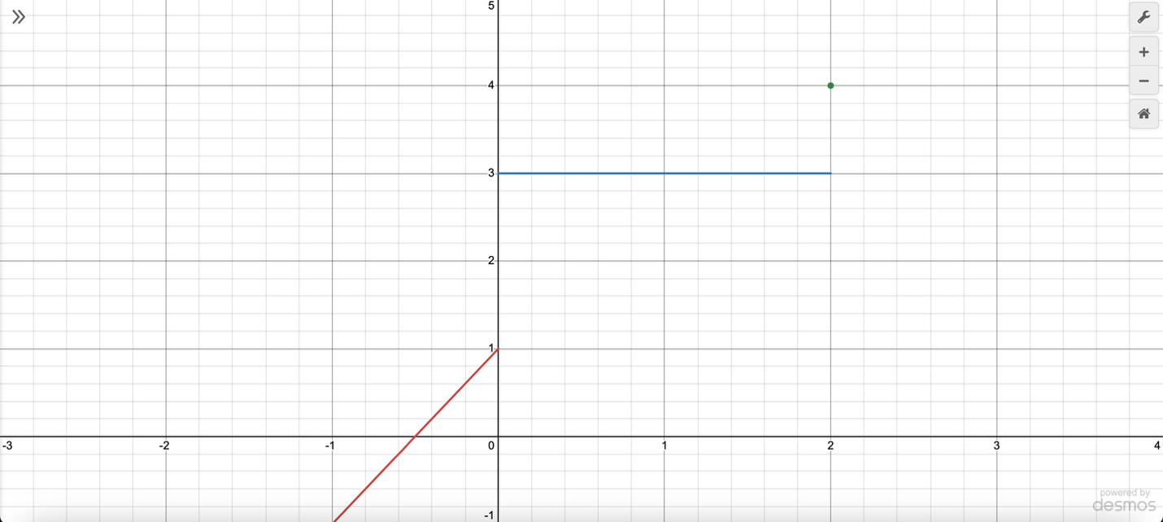
- Find $\lim_{x→-1}{f\left(x\right)}=-1$
- Find $\lim_{x→2}{f\left(x\right)}=3$
- Find $\lim_{x→0}{f\left(x\right)}=DNE$
- Find $f(2)=4$

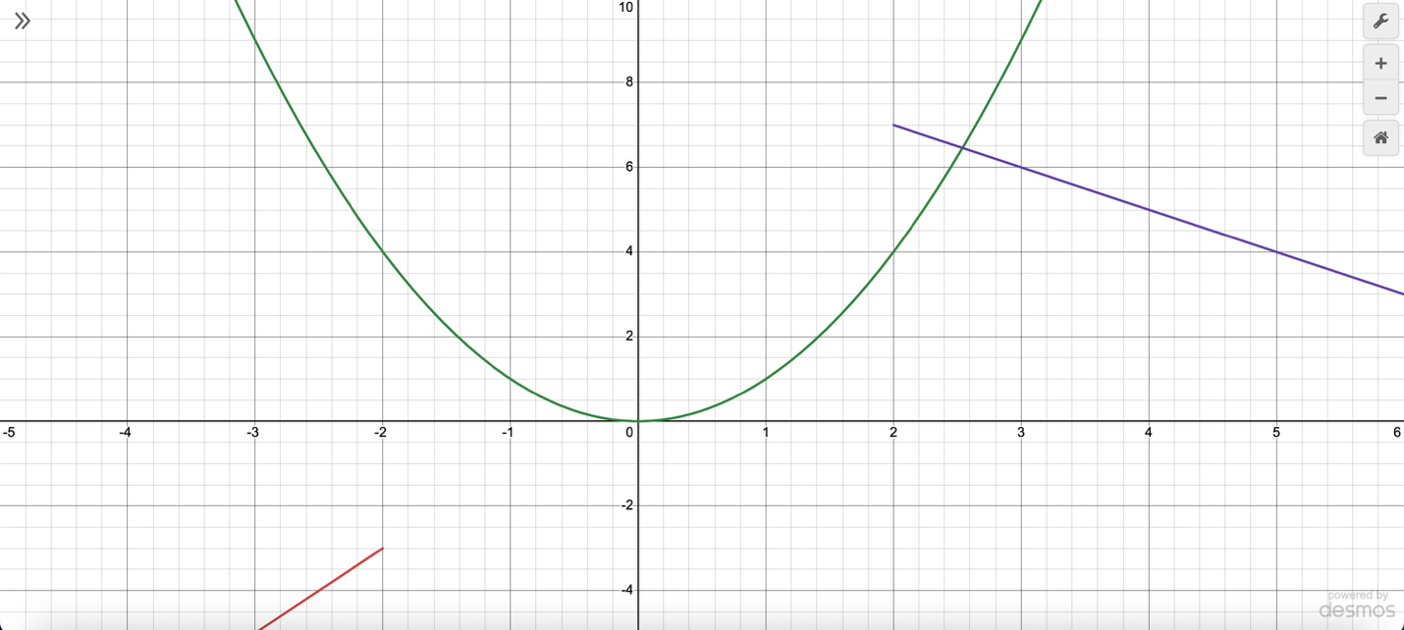
- Find $\lim_{x→3}{f\left(x\right)}=6$
- Find $\lim_{x→-2}{f\left(x\right)}=4$
- Find $\lim_{x→1}{f\left(x\right)}=1$
- Find $f\left(-2\right)=4$

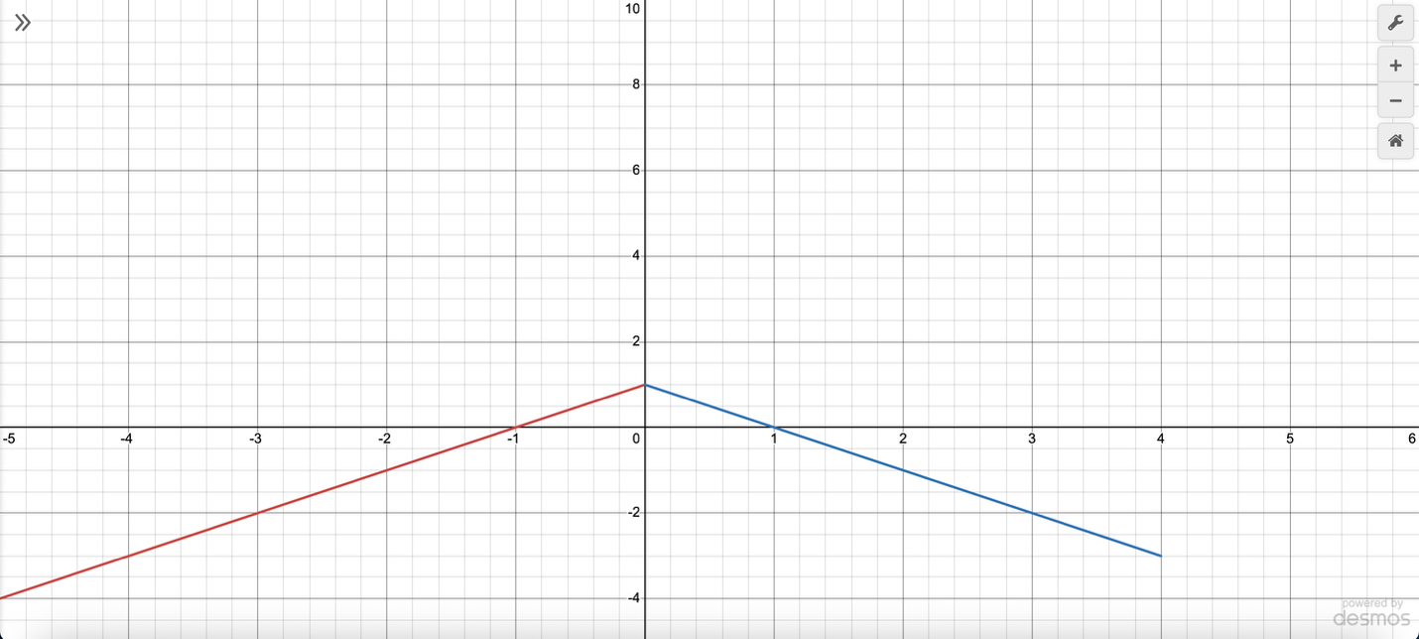
- Find $\lim_{x→0}{f\left(x\right)}=1$
- Find $\lim_{x→4}{f\left(x\right)}=-3$
- Find $\lim_{x→-1}{f\left(x\right)}=0$
- Find $f\left(4\right)=DNE$

Piecewise Function Limits
- For Questions 13-15, find the limit if it exists, using the following piecewise functions:
- $f\left(x\right)=\left\{\begin{aligned}10-2x^{2}, for x≤2 \\ x^{2}+4, for x>2\end{aligned}\right.$
  - Find $\lim_{x→2^{-}}{f\left(x\right)=2}$
  - Find $\lim_{x→2^{+}}{f\left(x\right)=8}$
  - Find $\lim_{x→2}{f\left(x\right)=DNE}$

- $f\left(x\right)=\left\{\begin{aligned}5x-7, for x≤0 \\ x^{2}+2x, for x>0\end{aligned}\right.$
  - Find $\lim_{x→0^{-}}{f\left(x\right)=-7}$
  - Find $\lim_{x→0^{+}}{f\left(x\right)=0}$
  - Find $\lim_{x→0}{f\left(x\right)=DNE}$

- $f\left(x\right)=\left\{\begin{aligned}-2x^{3}+1, for x≤3 \\ x+5, for x>3\end{aligned}\right.$
  - Find $\lim_{x→3^{-}}{f\left(x\right)=}-53$
  - Find $\lim_{x→3^{+}}{f\left(x\right)=8}$
  - Find $\lim_{x→3}{f\left(x\right)=DNE}$

Algebraic Limits
- Find $\lim_{x→2}{\frac{x^{2}-5x+6}{x-2}}$
-1
- Find $\lim_{x→4}{\frac{x^{2}-7x+10}{x-2}}$
-1
- Find $\lim_{x→5}{\frac{x^{2}-9x+14}{x-2}}$
-2

Asymptotes
- For Questions 19-21, find the vertical and horizontal asymptotes of the following functions and sketch the graphs.
- $f\left(x\right)=\frac{x^{2}-4x+3}{x^{2}-9}$
Vertical asymptote: x = -3
Horizontal asymptote: y = 1
- $f\left(x\right)=\frac{x^{2}-16}{x^{2}+6x+8}$
Vertical asymptote: x = -2
Horizontal asymptote: y = 1
- $f\left(x\right)=\frac{x^{2}+5x+6}{x^{2}-x-6}$
Vertical asymptote: x = 3
Horizontal asymptote: y = 1

Evaluate Limits
- For Questions 22-24, find the limits algebraically.
- $\lim_{x→5}{\frac{x-5}{x^{2}-6x+5}}$
$\frac{1}{4}$
- $\lim_{x→-3}{\frac{x+3}{x^{2}+5x+6}}$
-1
- $\lim_{x→4}{\frac{x-4}{x^{2}-6x+8}}$
$\frac{1}{2}$

Limits at Infinity
- For Questions 25-28, evaluate the limit at infinity algebraically.
- $\lim_{x→ ∞}{\frac{3x^{2}-x+4}{2x^{2}+7x-9}}$
$\frac{3}{2}$
- $\lim_{x→ -∞}{\frac{6x^{2}+3x+1}{4x^{2}-5x-10}}$
$\frac{3}{2}$
- $\lim_{x→ ∞}{\frac{-2x^{2}+x-5}{-2x^{2}-x+8}}$
1

Infinite Limits
- Find the infinite limits of $f\left(x\right)=\frac{-{(x-2)}^{2/3}}{\left|x+3\right|}$ and sketch the graph.
  - $\lim_{x→3^{-}}{f\left(x\right)=}-∞$
  - $\lim_{x→3^{+}}{f\left(x\right)=}-∞$
  - $\lim_{x→3}{f\left(x\right)=}-∞$

- Find the infinite limits of $f\left(x\right)=\frac{{(x+5)}^{2/3}}{\left|x-2\right|}$ and sketch the graph.
  - $\lim_{x→2^{-}}{f\left(x\right)=∞}$
  - $\lim_{x→2^{+}}{f\left(x\right)=}∞$
  - $\lim_{x→2}{f\left(x\right)=}∞$

- Find the infinite limits of $f\left(x\right)=\frac{-{(x-1)}^{2/3}}{\left|x+2\right|}$ and sketch the graph.
  - $\lim_{x→2^{-}}{f\left(x\right)=}-∞$
  - $\lim_{x→2^{+}}{f\left(x\right)=}-∞$
  - $\lim_{x→2}{f\left(x\right)=}-∞$

Limit Definition of the Derivative
- For Questions 31-33, find the limit definition of the derivative, $\lim_{h→0}{\frac{f\left(x+h\right)-f(x)}{h}}$, of the following function using the four steps.
- $f\left(x\right)=2x^{2}-3x+1$
  - Find $f(x+h)$
$2x^{2}+4xh+2h^{2}-3x-3h+1$
  - Find $f\left(x+h\right)-f(x)$
$4xh+2h^{2}-3h$
  - Find $\frac{f\left(x+h\right)-f(x)}{h}$
$4x+2h-3$
  - Find $\lim_{h→0}{\frac{f\left(x+h\right)-f(x)}{h}}$
$4x-3$

- $f\left(x\right)=-x^{2}+6x-4$
  - Find $f(x+h)$
$-x^{2}-2xh-h^{2}+6x+6h-4$
  - Find $f\left(x+h\right)-f(x)$
$-2xh-h^{2}+6h$
  - Find $\frac{f\left(x+h\right)-f(x)}{h}$
$-2x-h+6$
  - Find $\lim_{h→0}{\frac{f\left(x+h\right)-f(x)}{h}}$
$-2x+6$

- $f\left(x\right)=5x^{2}-2x+7$
  - Find $f(x+h)$
$5x^{2}+10xh+5h^{2}-2x-2h+7$
  - Find $f\left(x+h\right)-f(x)$
$10xh+{5h}^{2}-2h$
  - Find $\frac{f\left(x+h\right)-f(x)}{h}$
$10x+5h-2$
  - Find $\lim_{h→0}{\frac{f\left(x+h\right)-f(x)}{h}}$
$10x-2$

Derivative Rules
For Questions 34-42, find the derivatives for the functions below.
- $x^{18}+7$
$f^{'}\left(x\right)={18x}^{17}$

- $x^{12}-3$
$f^{'}\left(x\right)={12x}^{11}$

- $x^{9}+10$
$f^{'}\left(x\right)={9x}^{8}$

- ${4x}^{1.5}-\frac{x^{2.3}}{3}$
$f^{'}\left(x\right)={6x}^{0.5}-\frac{2.3}{3}x^{1.3}$

- ${3x}^{2.8}-\frac{{2x}^{1.6}}{5}$
$f^{'}\left(x\right)={8.4x}^{1.8}-\frac{3.2}{5}x^{0.6}$
- ${6x}^{1.2}-\frac{{3x}^{2.5}}{4}$
${f^{'}\left(x\right)=7.2x}^{0.2}-\frac{7.5}{4}x^{1.5}$
- $x^{3/4}-5x^{2/3}+3x^{-1/2}$
$f^{'}\left(x\right)=\frac{3}{4}x^{-1/4}-\frac{10}{3}x^{-1/3}-\frac{3}{2}x^{-3/2}$
- ${2x}^{5/6}+4x^{-2/3}-x^{1/3}$
$f^{'}\left(x\right)=\frac{5}{3}x^{-1/6}-\frac{8}{3}x^{-5/3}-\frac{1}{3}x^{-2/3}$
- ${7x}^{-1/4}-x^{3/5}+5x^{1/2}$
$f^{'}\left(x\right)=-\frac{7}{4}x^{-5/4}-\frac{3}{5}x^{-2/5}+\frac{5}{2}x^{-1/2}$

Rate of Change Application and Interpretation
- A computer screen company has, on average, an employee can assemble N(t) screens per day after t days of on the job training, given by $N\left(t\right)=25+60t^{-1}$, where $t≥1.5$.
  - Find the derivative
$N\left(t\right)=-60t^{-2}$
  - Find N(5) and N’(5) and interpret the results with a short sentence.
$N\left(5\right)=37$; After 5 days of training, the employee assembles 37 screens per day.
$N^{'}(5)=-2.4$; After 5 days of training, the assembly rate is decreasing at about 2.4 screens per day.

- On average, a car manufacturing company have new employees that can assemble N(t) components per day after t days of on the job training, given by $N\left(t\right)=40-50t^{-1}$, where $t≥1.5$.
  - Find the derivative
$N\left(t\right)=50t^{-2}$
  - Find N(5) and N’(5) and interpret the results with a short sentence.
$N\left(5\right)=30$; After 5 days of training, the employee assembles 30 components per day.
$N'\left(5\right)=2$; After 5 days of training, the assembly rate is increasing by 2 components per day.

- An employee for a satellite company can, on average, assemble N(t) components per day after t days of on the job training, given by $N\left(t\right)=35+70t^{-1}$, where $t≥1.5$.
  - Find the derivative
$N\left(t\right)=-70t^{-2}$
  - Find N(5) and N’(5) and interpret the results with a short sentence.
$N\left(5\right)=49$; After 5 days of training, the employee assembles 49 components per day.
$N'\left(5\right)=-2.8$; After 5 days of training, the assembly rate is decreasing at about 2.8 components per day.

Tangent Line
- For Questions 49-51, find the following:
- Find the ordered pair
- Find the slope
- Use point-slope form to find the tangent line

- $f\left(x\right)=2x^{5}-4x^{2}+6$ at x = 2
Ordered pair: (2,54)
Derivative: $f'\left(x\right)=10x^{4}-8x$
Slope: $m=144$
Equation: $y=144x-234$
- $f\left(x\right)=-3x^{4}+x^{3}-1$ at x = -1
Ordered pair: (-1,-5)
Derivative: $f'\left(x\right)=-12x^{3}+{3x}^{2}$
Slope:$m=15$
Equation: $y=15x+10$
- $f\left(x\right)=x^{3}-5x+8$ at x = 0
Ordered pair: (0,8)
Derivative: $f'\left(x\right)={3x}^{2}-5$
Slope: $m=-5$
Equation: $y=-5x+8$

Average Rate of Change
- The function $f\left(x\right)=2x^{2}-3x$ represents an object in motion, when x is seconds and f(x) is meters. Find the average velocity from 1 to 4 seconds.
$\frac{20-(-1)}{4-1}=7$ m/s
- The function $y=-x^{2}+5x$ represents an object in motion, when x is seconds and y is meters. Find the average velocity from 0 to 3 seconds.
$\frac{6-0}{3-0}=2$ m/s
- The function $f\left(x\right)=x^{2}-4x+6$ represents an object in motion, when x is seconds and f(x) is meters. Find the average velocity from 2 to 5 seconds.
$\frac{11-2}{5-2}=3$ m/s

Revenue, Cost, and Profit Functions
- For Questions 52-54, determine:
- The revenue function R(x) and its domain.
- The marginal revenue at a given x value and interpret the result.
- The profit function P(x).
- The marginal profit at a given x value and interpret the result.

- A technology company provides the price-demand equation $p(x)=50-0.01x$, while its cost function is given by $C(x)=5000+7x$. Find the required functions at x = 1200.
a) $R(x)=50x–0.01x^{2}$, D: 0 ≤ x ≤ 5000
b) $R' (x)=50–0.02x$, R′ (1200) = $26 , At a production level of 1200, the technology company’s revenue would increase $26 for an additional unit sold.
c) $P(x)=–0.01x^{2}+43x–5000$
d) $P' (x)=–0.02x+43$, P′ (1200) = $19 , At a production level of 1200, the technology company’s profit would increase $19 for producing one more unit.

- A fitness equipment company has the price-demand equation $p(x)=75-0.02x$ and cost function $C(x)=3000+5x$. Find the required functions at x = 800.
a) $R(x)=75x–0.02x^{2}$, D: 0 ≤ x ≤ 3750
b) $R^{'}\left(x\right)=75-0.04x$, R′ (800) = $43 , At a production level of 800, the fitness equipment company’ revenue would increase $43 for an additional unit sold.
c) $P\left(x\right)=-0.02x^{2}+70x-3000$
d) $P^{'}\left(x\right)=-0.04x+70$, P′ (800) = $38 , At a production level of 800, the fitness equipment company’s profit would increase $38 for producing one more unit.

- A sunglasses manufacturer has the price-demand equation $p(x)=40-0.005x$ and cost function $C(x)=2500+6x$. Find the required functions at x = 1500.
3a) $R\left(x\right)=40x-0.005x^{2}$, D: 0 ≤ x ≤ 8000
3b) $R^{'}\left(x\right)=40-0.01x$, R′ (1500) = $25 , At a production level of 1500, the sunglasses manufacturer’s revenue would increase $25 for an additional unit sold.
3c) $P\left(x\right)=-0.005x^{2}+34x-2500$
3d) $P^{'}\left(x\right)=-0.01x+34$, P′ (1500) = $19 , At a production level of 1500, the sunglasses manufacturer’s profit would increase $19 for producing one more unit.

Marginal and Exact Cost
- For Questions 55-57, determine:
- The exact cost of producing the item.
- The marginal cost of producing the item.

- The total cost of producing x smartphones is given by $C(x)=4000+60x-0.3x^{2}$. Approximate the cost of producing the 101st smartphone using both marginal and exact cost.
a) –$0.30
b) $0
- The total cost of producing x electric bikes is given by $C(x)=5000+80x-0.5x^{2}$. Approximate the cost of producing the 61st bike using both marginal and exact cost.
a) $19.50
b) $20
- The total cost of producing x coffee machines is given by $C(x)=3000+50x-0.2x^{2}$. Approximate the cost of producing the 91st machine using both marginal and exact cost.
a) $13.80
b) $14

Average Cost & Marginal Average Cost
- For Questions 58-60, determine:
- The average cost function.
- The marginal average cost at a given x value and interpret the result.

- The cost function for producing chairs is given by $C(x)=6000+100x-0.4x^{2}$. Find the marginal average cost at x = 40.
a) $\overline{C}\left(x\right)=6000x^{-1}+100-0.4x$
b) –$4.15
- The cost function for producing unicycles is given by $C(x)=7000+90x-0.3x^{2}$. Find the marginal average cost at x = 30.
a) $\overline{C}(x)=7000x^{-1}+90–0.3x$
b) –$8.08
- The cost function for producing speakers is given by $C(x)=8000+120x-0.5x^{2}$. Find the marginal average cost at x = 50.
a) $\overline{C}\left(x\right)=8000x^{-1}+120-0.5x$
b) –$3.70

Compounding
- How long will it take money to quadruple if it is invested at 4.75% compounded continuously?
4 = 1e^{0.0475t}
t = 29.19 years
- How long will it take for an investment to double if it is compounded continuously at an interest rate of 3.8%?
2 = 1e^{0.038t}
t = 18.24 years
- If $200 is invested at 7% compounded continuously, what is the amount in the account after 6 years?
A = 200e^{(0.07)(6)}
A = $304.39
- If $500 is invested at 5.5% compounded annually, what is the balance after 10 years?
A = 500(1 + $\frac{0.055}{1}$)⁽¹⁾⁽¹⁰⁾
A = $854.07
- If $1,000 is invested at 6.25% compounded monthly, how much will be in the account after 12 years?
A = 1000(1 + $\frac{0.0625}{12}$)⁽¹²⁾⁽¹²⁾
A = $2112.88

Derivatives of Exponential and Log Functions
- For Questions 66-71, find the derivative of each function:

- $f(x)=lnx^{5}–5e^{x}+2x^{3}$
$f^{'}\left(x\right)=\frac{5}{x}-5e^{x}+6x^{2}$
- $f(x)=5\log_{2}{x}+e^{10}$
$f'(x)=\frac{5}{xln2}$
- $f(x)=(4+6x)(2+5e^{x})$
$f'(x)=50e^{x}+30xe^{x}+12$
- $f(x)=(3+x)(1+2e^{x})$
$f'(x)=8e^{x}+2xe^{x}+1$
- $f(x)=6x^{5}(x^{2}–8)$
$f^{'}\left(x\right)=42x^{6}-240x^{4}$

- $f(x)=8x^{3}(x^{4}–7)$
$f^{'}\left(x\right)=56x^{6}-168x^{2}$

Tangent Lines
- Find the equation of the line tangent to $f(x)=40+3lnx$ at x = 2.
Ordered pair: (2, 42.08)
Derivative: f ′ (x) = $\frac{3}{x}$
Slope: $\frac{3}{2}$ or 1.5
Equation: y = 1.5x + 39.08
- Find the equation of the line tangent to $f(x)=50+4lnx$ at x = 3.
Ordered pair: (3, 54.39)
Derivative: f ' (x) = $\frac{4}{x}$
Slope: $\frac{4}{3}$ or 1.33
Equation: y = $\frac{4}{3}$ + 50.39

Rate of Change
- The population of a small town (in thousands) is modeled by $P(t)=200e^{0.02t}$, where t = 0 in for the year 2000. Find the rate of change in population in the year 2025.
P′ (t) = 4e^{0.02t}
P′ (25) = 6.59 thousand people per year
- A streaming service’s number of subscribers (in thousands) is modeled by $S(t)=500e^{0.05t}$, where t is measured in months since the service launched. Find the rate at which the subscriber count is changing after 12 months.
S′ (t) = 25e^{0.05t}
S′ (12) = 45.55 thousand subscribers per month

Applications of Derivatives of Products and Quotients
- For Questions 76-78, find the derivative f ′(x). Then evaluate and interpret the results at a specific value of x:

- A company sells a product where the price per unit and the number of units sold depend on time t (in months). The revenue function is given by $R(t)=(5t+20)(t^{2}+3)$. Find R′ (t), then evaluate and interpret R(4) and R′ (4).
$R' (t)=15x^{2}+40x+15$
R(4) = $760 , After 4 months, the company has made a total of $760.
R′ (4) = $415 , After 4 months, the company’s revenue is increasing at a rate of $415 per month.
- The click-through rate (CTR) for an online ad campaign, measured in percentage per hour after launch, is given by $CTR(t)=\frac{0.2t}{t^{2}+2}$, where t is the number of hours since the ad went live. Find CTR′ (t), then evaluate and interpret CTR(6) and CTR′ (6).
$CTR' (t)=\frac{-0.2t^{2} + 0.4}{{(t^{2}+2)}^{2}}$
CTR(6) = 0.03 , After 6 hours, the online ad campaign has a total of 3% of people visiting per hour.
CTR′ (6) = –0.005 , After 6 hours, the online ad campaign click-through rate is decreasing at a rate of 0.05% per hour.
- The efficiency E(t) of a factory machine (in units produced per hour) after t hours of operation is modeled by $E(t)=\frac{5t}{t^{2}+4}$. Find E′ (t), then evaluate and interpret E(8) and E′ (8).
$E' (8)=\frac{-5t^{2} + 20}{{(t^{2}+4)}^{2}}$
E(8) = 0.59 , After 8 hours, the factory machine has produced 0.59 units per hour.
E′ (8) = –0.06 , After 8 hours, the factory machine’s efficiency is decreasing at a rate of 0.06 units per hour.

Relative Rate of Change
- Given a function $f\left(x\right)=x^{4}-5x^{3}+4x$, compute the percentage relative rate of change at x = 3. Round your answer to the nearest hundredth.
$\frac{4x^{3}-15x^{2}+4}{x^{4}-5x^{2}+4x}$, 54.76%
- For the function $f\left(x\right)=2x^{3}-7x^{2}+9x$, determine the percentage relative rate of change at x = 4. Express your answer as a percentage rounded to two decimal places.
$\frac{6x^{2}-14x+9}{{2x}^{3}-7x^{2}+9x}$, 94.23%
- If $f\left(x\right)=x^{5}-3x^{2}+6$, find the percentage relative rate of change at x = 25. Round your answer to the nearest hundredth.
$\frac{5x^{4}-6x}{x^{5}-3x^{2}+6}$, 20%

Elasticity of Demand
- The price-demand function is given as $f\left(p\right)=150-5p$. Compute the elasticity of demand at p = 25 and determine if the demand is elastic, inelastic, or unit elastic.
$E\left(p\right)=\frac{5p}{150-5p}=\frac{p}{30-p}$
$E\left(25\right)=5$, elastic
- For the function $f\left(p\right)=135-3p$, calculate the price elasticity of demand at p = 15. Based on your result, classify the demand as elastic, inelastic, or unit elastic.
$E\left(p\right)=\frac{3p}{135-3p}=\frac{p}{45-p}$
$E\left(15\right)=0.5$, inelastic
- Given the demand function $f\left(p\right)=200-4p$, find the elasticity at p = 30. Is the demand elastic, inelastic, or unit elastic?
$E\left(p\right)=\frac{4p}{200-4p}=\frac{p}{50-p}$
$E\left(30\right)=\frac{3}{2} or 1.5$, elastic
- If the price elasticity of demand for a product is 0.7 at a given price, explain whether the demand is elastic or inelastic. What effect will a price increase have on demand?
Inelastic, if the price increases there would be a smaller change in demand.
- A product has an elasticity of demand equal to 2.1 at a certain price. Discuss whether the demand is elastic or inelastic. What happens to the demand if the price increases?
Elastic, if the price increases there would be a larger change in demand.
- Suppose a company determines that the price elasticity of demand at a certain price is 1.0. Explain how total revenue would respond to price changes.
Unit, if the price increases there would be an equal change in demand.
- If the price elasticity of demand is 1.2 at a certain price level, what effect would an increase in price have on total revenue?
If the price increased, total revenue would decrease.
- Given that the elasticity of demand at a specific price is 0.5, predict the impact of a price increase on total revenue.
If the price increased, total revenue would also increase.
- A company estimates the price elasticity of demand for a product to be exactly 1 at a certain price. How will increasing the price affect total revenue?
If the price increased, total revenue would stay the same.

Local Extrema and Critical Numbers
- For Questions 91-93, use each function to complete the following:
- Find and determine the critical numbers.
- Identify the intervals where the function is increasing and decreasing.
- Determine whether any local extrema are maxima or minima and state their values

- $f\left(x\right)=36x^{3}-27x+4$
Critical numbers: x = -0.5, 0.5
Increasing: $(-∞,-0.5)∪(0.5,∞)$, Decreasing: $(-0.5, 0.5)$
Local Max: $(-0.5, 13)$, Local Min: $(0.5, -5)$
- $f\left(x\right)=45x^{3}-30x+12$
Critical numbers: x = -0.4714, 0.4714
Increasing: $\left(-∞,-0.47\right)∪\left(0.47,∞\right)$, Decreasing: $\left(-0.47, 0.47\right)$
Local Max: $(-0.47, 21.43)$, Local Min: $(0.47, 2.57)$
- $f\left(x\right)=6x^{3}-27x^{2}+7$
Critical numbers: x = 0, 3
Increasing: $(-∞,0)∪(3,∞)$, Decreasing: $(0, 3)$
Local Max: $(0, 7)$, Local Min: $(3, -74)$

Chain Rule
- For Questions 94-102, find the derivative and simplify.

- $f\left(x\right)=8{\left(x^{2}+5\right)}^{-4}$
$f'\left(x\right)=-64x({x^{2}+5)}^{-5} or \frac{-64x}{({x^{2}+5)}^{5}}$
- $f\left(x\right)=7{\left(x^{2}+4\right)}^{-3}$
$f'\left(x\right)=-42x({x^{2}+4)}^{-4} or \frac{-42x}{({x^{2}+4)}^{4}}$
- $f\left(x\right)=9{\left(x^{2}+2\right)}^{-6}$
$f'\left(x\right)=-108x({x^{2}+2)}^{-7} or \frac{-108x}{({x^{2}+2)}^{7}}$
- $f\left(x\right)={\left(3x-2\right)}^{4}-4lnx$
$f'\left(x\right)=12({3x-2)}^{3}-\frac{4}{x}$
- $f\left(x\right)={\left(4x+1\right)}^{3}-2lnx$
$f'\left(x\right)=12({4x+1)}^{2}-\frac{2}{x}$
- $f\left(x\right)={\left(x-3\right)}^{4}-5lnx$
$f'\left(x\right)=4({x-3)}^{3}-\frac{5}{x}$
- $f\left(x\right)=5x-ln⁡(x^{2}+2)$
$f^{'}(x)=5-\frac{2x}{(x^{2}+2)}$
- $f\left(x\right)=6x-ln⁡(x^{4}+5)$
$f^{'}(x)=6-\frac{4x^{3}}{(x^{4}+5)}$
- $f\left(x\right)=3x-\ln\left({2x}^{3}+3\right)$
$f^{'}(x)=3-\frac{6x^{2}}{({2x}^{3}+3)}$

Absolute Extrema
- For Questions 103-105, find the absolute maximum and minimum values for each function on the given interval. Use derivative and critical numbers.

- $f\left(x\right)=10x^{3}-60x^{2}+90x-5$, Domain: [-4, 6]
$f^{'}\left(x\right)=30x^{2}-120x+90$
Critical numbers: x = 1, 3
Absolute Max: (6, 540), Absolute Min: (-4, -1960)
- $f\left(x\right)=4x^{3}-18x^{2}+24x+8$, Domain: [-2, 5]
$f^{'}\left(x\right)=12x^{2}-36x+24$
Critical numbers: x = 1, 2
Absolute Max: (5, 178), Absolute Min: (-2, -144)
- $f\left(x\right)=15x^{2}-180x+105$, Domain: [-1, 8]
$f^{'}\left(x\right)=30x-180$
Critical number: x = 6
Absolute Max: (-1, 300), Absolute Min: (6, -435)

Revenue, Profit, and Pricing
- For Questions 106-108, use a company’s cost function and price-demand function to answer the following problems:
- Write the revenue function.
- Find the domain of the revenue function.
- Determine the maximum revenue and the quantity that achieves it.
- Write the profit function.
- Find the maximum profit and the corresponding quantity.
- Identify the price per unit for maximum profit.

- $C\left(x\right)=25000+12x, p\left(x\right)=300-0.2x$
a) $R\left(x\right)=300x-0.2x^{2}$
b) Domain: $0≤x≤1500$
c) Maximum Revenue: $112,500 at 750 units
d) $P\left(x\right)=-0.2x^{2}+288x-25000$
e) Maximum Profit: $78,680 at 720 units
f) $p\left(720\right)=\$156$ per unit
- $C\left(x\right)=40000+10x, p\left(x\right)=275-0.5x$
a) $R\left(x\right)=275x-0.5x^{2}$
b) Domain: $0≤x≤550$
c) Maximum Revenue: $37,812.50 at 275 units
d) $P\left(x\right)=-0.5x^{2}+265x-40000$
e) Maximum Profit: $-$$4,887.50 at 265 units
f) $p\left(265\right)=\$142.50$ per unit
- $C\left(x\right)=50000+18x, p\left(x\right)=320-0.2x$
a) $R\left(x\right)=320x-0.2x^{2}$
b) Domain: $0≤x≤1600$
c) Maximum Revenue: $128,000 at 800 units
d) $P\left(x\right)=-0.2x^{2}+302x-50000$
e) Maximum Profit: $64,005 at 755 units
f) $p\left(755\right)=\$169$ per unit

Marginal Cost Antiderivative
- Find the antiderivative of marginal cost $C' (x)=4x^{2}-3x$ with a fixed cost of $120. Then find the cost of producing 25 units.
$C(x)=\frac{4x^{3}}{3}-\frac{{3x}^{2}}{2}+120$
$C(30)=\$20,015.83$
- Find the antiderivative of marginal cost $C' (x)=6x^{2}-x$ given a fixed cost of $200. Find the cost for 20 units.
$C(x)={2x}^{3}-\frac{x^{2}}{2}+200$
$C(20)=\$16,000$
- Find the antiderivative of marginal cost $C' (x)=3x^{2}-5x$ if the fixed cost is $175. Find the cost of producing 40 units.
$C(x)=x^{3}-\frac{{5x}^{2}}{2}+175$
$C(40)=\$60,175$

Area Approximation
- Approximate the area under $f(x)=3x+2$ from x = 2 to x = 3 using 4 right rectangles. Is it an overestimate or underestimate? Find the error bound. How many rectangles are needed to reduce the error below 0.02?
Area: $R_{4}=9.875$
Overestimate
Error Bound: 0.75
Rectangles needed: n = 150
- Approximate the area under $f(x)=x+4$ from x = 0 to x = 2 using 4 left rectangles. Is it an overestimate or underestimate? Find the error bound. How many rectangles are needed to reduce the error below 0.025?
Area: $L_{4}=9.5$
Underestimate
Error Bound: 1
Rectangles needed: n = 160
- Approximate the area under $f(x)=5x+1$ from x = 1 to x = 3 using 4 right rectangles. Is it an overestimate or underestimate? Find the error bound. How many rectangles are needed to reduce the error below 0.005?
Area: $R_{4}=24.5$
Overestimate
Error Bound: 5
Rectangles needed: n = 4000

Areas
- Find the area between −2 and 0.
  - A = −0.2241 (−2 to −1)
  - B = 1.0415 (−1 to 0)
  - C = −0.3897 (0 to 1.5)
A + B
Area = 0.8174
- Find the area between −1.5 and 1.
  - A = −0.1345 (−1.5 to −0.5)
  - B = 1.1282 (−0.5 to 1)
  - C = −0.4568 (1 to 2.5)
A + B
Area = 0.9937
- Find the area between −2 and −0.5.
  - A = −0.1345 (−2 to −1)
  - B = 1.1282 (−1 to 0)
  - C = −0.4568 (0 to 2)
A + ½ B
Area = 0.4296

Population Growth Define Integral
- The city's population growth rate is $P' (t)=25\sqrt{t+3}$ people per year over 0 ≤ t ≤ 12. Find how many people are added over the first 6 years.
$P(t)=\frac{{50(t+3)}^{3/2}}{3}$
$P(6)-P(0)=363$ people
- The city's population growth rate is $P' (t)=20\sqrt{t+4}$ people per year over 0 ≤ t ≤ 20. Find how many people are added over 5 years.
$P(t)=\frac{{40(t+4)}^{3/2}}{3}$
$P(5)-P(0)=253$ people
- The city's population growth rate is $P' (t)=35\sqrt{t+1}$ people per year over 0 ≤ t ≤ 8. Find how many people are added over the first 4 years.
$P(t)=\frac{{70(t+1)}^{3/2}}{3}$
$P(4)-P(0)=237$ people

Antiderivatives
For Questions 121-132, find the antiderivatives:
- $∫\left(4x^{5}-7x^{2}+1\right)dx$
$f(x)=\frac{{2x}^{6}}{3}-\frac{{7x}^{3}}{3}+x+C$
- $∫(5x^{4}-6x^{3}+3) dx$
$f(x)=x^{5}-\frac{{3x}^{4}}{2}+3x+C$
- $∫(2x^{6}-9x^{3}+5) dx$
$f(x)=\frac{{2x}^{7}}{7}-\frac{{9x}^{4}}{4}+5x+C$
- $∫5x{\left(x^{2}+3\right)}^{6} dx$
$f(x)=\frac{{5(x^{2}+3)}^{7}}{14}+C$
- $∫{6x(x^{2}+2)}^{5} dx$
$f(x)=\frac{{(x^{2}+2)}^{6}}{2}+C$
- $∫3x{(x^{2}+4)}^{8} dx$
$f(x)=\frac{{(x^{2}+4)}^{9}}{3}+C$
- $∫\frac{5x^{4}}{{(2+x^{5})}^{5}} dx$
$f(x)=-\frac{{(2+x^{5})}^{-4}}{4}+C$
- $∫\frac{6x^{5}}{{(4+x^{6})}^{4}} dx$
$f(x)=-\frac{{(4+x^{6})}^{-3}}{3}+C$
- $∫\frac{8x^{7}}{{(5+x^{8})}^{7}} dx$
$f(x)=-\frac{{(5+x^{8})}^{-6}}{6}+C$
- $∫\frac{4+x^{2}}{x} dx$
$f(x)=4ln\left|x\right|+\frac{x^{2}}{2}+C$
- $∫\frac{5+x^{2}}{x} dx$
$f(x)=5ln\left|x\right|+\frac{x^{2}}{2}+C$
- $∫\frac{7+x^{2}}{x} dx$
$f(x)=7ln\left|x\right|+\frac{x^{2}}{2}+C$

Marginal Cost Define Integral
- A motorcycle company produced the marginal cost function $C' (x)=400-\frac{x}{4}$. Find the increase in cost from 300 motorcycles to 700 motorcycles.
$C\left(x\right)=400x-\frac{x^{2}}{8}$
$C\left(700\right)-C(300)=\$110,000$
- A jet ski manufacturer produced the marginal cost function $C' (x)=550-\frac{x}{5}$. Find the increase in cost from 500 jet skis to 900 jet skis.
$C(x)=550x-\frac{x^{2}}{10}$
$C\left(900\right)-C(500)=\$164,000$
- A video game company produced the marginal cost function $C' (x)=600-\frac{x}{6}$. Find the increase in cost from 400 games to 800 games.
$C(x)=600x-\frac{x^{2}}{12}$
$C\left(800\right)-C(400)=\$200,000$

Average Value
- Find the average value of $f(x)=25e^{0.03x}$ over the interval [5,25].
$F(x)=41.67e^{0.03x}$
$F\left(25\right)-F(5)=39.80$
- Find the average value of $f(x)=30e^{0.02x}$ over the interval [0,20].
$F(x)=75e^{0.02x}$
$F\left(20\right)-F(0)=36.89$
- Find the average value of $f(x)=35e^{0.05x}$ over the interval [8,28].
$F(x)=35e^{0.05x}$
$F\left(28\right)-F(8)=89.72$

Antiderivative Through Points
- Find the antiderivative of $\int{15x^{-6} dx}$, then find the function if it passes through the point (2,5).
$f(x)=-3x^{-5}+C$
$f\left(x\right)=-3x^{-5}+5.09$
- Find the antiderivative of $\int{10x^{-5} dx}$, then find the function if it passes through the point (1,3).
$f\left(x\right)=-\frac{5}{2}x^{-4}+C$
$f\left(x\right)=-\frac{5}{2}x^{-4}+5.5$
- Find the antiderivative of $\int{12x^{-8} dx}$, then find the function if it passes through the point (2,6).
$f(x)=-\frac{12}{7}x^{-7}+C$
$f\left(x\right)=-\frac{12}{7}x^{-7}+6.01$

